Day in the Life of the Hudson River 10/14/21
Lasher Park, Germantown
RIVER MILE: 108.5
Salt Front: ~ 49
Heidi Block & Columbia Land Conservancy & Jim McDarby & Hudson High School
35 students & 9 adults
Latitude 42.158 N & Longitude – 73.888 W
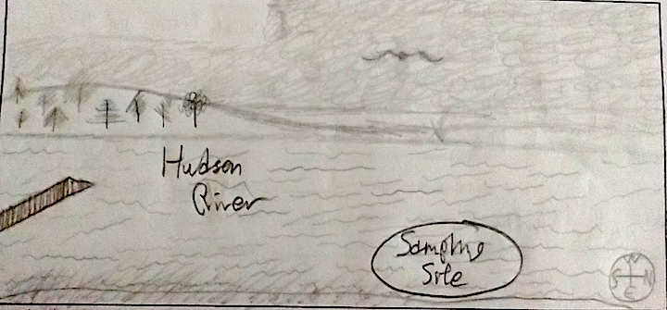
Location: Lasher Memorial Park, Boat Launch, Northern Germantown Landing, Columbia County, NY
Area: Grassy area, concrete boat launch, pier, parking lot- used for picnics and boating, farmland uphill
Surrounding Land Use: 5% Forested; 80% Urban/Residential; 5% Beach; 10% Industrial/Commercial
Sampling Site: Park with mowed lawn, beach, riprap in area
Shoreline: 75% Sandy; 20% muddy; 5% rocky
Water: muddy, murky
River Bottom: Muddy, weedy, sandy
Plants in water: water chestnuts, duckweed
*NR = Not read/recorded
ITEM |  | Time |  | Reading |  |  |  | Comments
Physical
Air Temperature |  | 11:04 AM |  | 21 º C |  |  | 69.8º F
Wind Speed: |  | 11:06 AM |  | Anemometer  NR |  |  | Beaufort  1 | Direction  SE
Weather today |  | 11:07 AM |  | >75% cloud cover |  |  | No rain
Weather the past 3 days: |  | unseasonably warm, mostly cloudy, muggy
Tides- |  | Time |  | Rising, Falling, Unchanged |  |  | Height (cm)
 |  | 9:54 AM  10:19 AM  10:48AM  12:37 PM |  | Rising  Slack  Falling  Falling |  |  | 81.28 cm  81.28 cm  78.74 cm  55.88 cm | LT: 9:54 AM  HT: 3:40 PM
Current- |  | Time |  | Cm/sec |  | Knots | North/South | Ebb/Flood/Slack
 |  | 9:47 AM  11:02 AM  12:44 PM |  | 20  0  17 |  |  | N  NA  S | Flooding  Still/Slack  Ebbing
Water Temperature- |  | 11:10 AM |  | 18º C |  |  | 64º F
Turbidity- Secchi Disk |  | 11:21 AM |  | 96 cm
Chemical
Salinity- Low Range Quantabs |  | 9:31 AM |  | 37 ppm Cl- |  |  | 67 ppm TS
Standardized Salinity |  | NR |  | NR
DO – |  | Time |  | Temp |  |  | ppm DO | % Saturation
***NOT USEFUL DATA |  | 11AM |  | 18º C |  |  | 26ppm*** must be an error - not added to database | >140%
pH – color match kit |  | 11:05 AM |  | 8.5
Nitrates- |  | NR |  | NR
Phosphates- |  | NR |  | NR
Biological
Fish – seined 8 times |  | Number |  | Name |  |  | Length of longest | Length of smallest
 |  | 15  9  1  5  2  2 |  | Herring sp.  Spottail Shiner  Banded Killifish  White Perch  Striped Bass  Smallmouth Bass |  |  | 6.5 cm  12.5 cm  6 cm  15 cm  7.5 cm  11 cm | 6 cm  6 cm  NA  11 cm  6 cm  10 cm
Fish Totals |  | TOTAL:  34 |  | Diversity: 6
Macroinvertebrates |  | Number |  | Name |  |  | Length of longest | Length of smallest
Macroinvertebrate Totals |  | TOTAL: 0 |  | Diversity: 0
Other Observations
Lots of eagles and at least one osprey
Hear – crickets, birds, boats
Feel – humidity, muggy
See – trees, greenish water
Sediment Core
Length | H2S smell |  | Oxid Top |  | Oil |  | Grain Size | Other Features
Not collected
Boats- NR
 | Time |  | Name |  | Color |  | North/Southbound | Light/Loaded
Commercial | 12:35 |  | Tug |  | Green & White |  | North bound | Loaded
 | 12:30 |  | Barge |  | Blue & Black |  | North bound | Loaded
 | 12:30 |  | Barge |  | Red & Black |  | South bound | Light
Residential | 2:44 PM |  | Cabin |  | White |  | Northbound
 | 10:36 |  | Sail |  | White |  | Southbound

